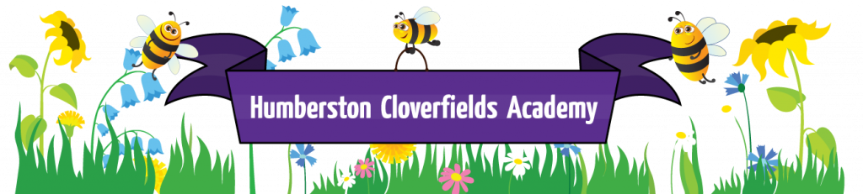

Sex and relationships Policy

Intent
The focus in our academy is teaching the characteristics of positive relationships, with particular reference to friendships, family relationships and relationships with other children and adults.
By the time a child leaves Cloverfields, they will have learnt about, and understood how to:
establish personal space and boundaries enabling them to understand how to keep themselves safe.
show respect for others and develop mutually respectful relationships.
maintain positive and safe relationships online.
take care of their own emotional and mental well-being, and how others can support them. Equally, how they can be a support to others.
have the confidence to speak to a trusted ‘other’ when they know something is wrong or worrying them.
and know that families include a variety of family structures including: single parent families, LGBT families, families headed by grandparents or other relatives, adoptive parents, foster parents and carers.
Following the statutory guidelines, we will teach a sex education programme from Reception through to Year 6. This will be

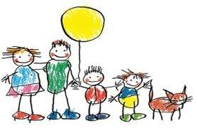

tailored to the age and the physical and emotional maturity of the pupils.
Children will be taught
To recognise and name the external parts of the body, including agreed names for sexual parts.
To know about human life processes such as conception, birth and puberty.
To develop an understanding of the physical and emotional aspects of puberty.
To know who can provide help and support.

Implementation
All pupils, whatever their experience, background and identity, are entitled to quality RSE that helps them build confidence and a positive sense of self. It is not taught in isolation, but firmly embedded in all curriculum areas including PSHE, ICT (staying safe online), Science and PE.
SRE is normally delivered by the class teacher with support as appropriate. It is normally taught in mixed gender groups other than when it is deemed more appropriate for topics to be covered in single sex groups.
Language
It is good practice to use the correct terms for all body parts, Ofsted fully supports this approach and as a result, pupils will be taught the correct terms for body parts from Nursery.
Dealing with difficult questions
We acknowledge that sensitive and potentially difficult questions will arise in RSE as pupils will naturally share information and ask questions. Discussion will always be guided by the teacher to cover the aims and curriculum content of the RSE, on these occasions, appropriate questions will be answered whole class. If questions arise that are beyond the taught curriculum for that age group, they will be answered in a sensitive and age appropriate way to the individual child (ren) who asked the question.
Ground rules will be set before sessions when discussing sensitive subject matters, for example:
Pupils will be encouraged to write down questions or concerns, anonymous if desired, and posted in a box ready to be answered later.
Children will be discouraged from talking about sensitive issues in the playground and around school after lessons, thereby breaking trust.
The sharing of personal information or experiences whole class will be discouraged, if inappropriate. However, support will be given to the child concerned after the session to resolve issues.
If serious concerns arise out of a session, the teacher may inform parents or the safeguarding team.

The rights of parents
Parents/carers have the right to withdraw their children from all or part of the SRE provided at the academy EXCEPT for those areas included in the statutory National Curriculum Science. Those who wish to exercise this right should discuss this with the Principal and make it clear which aspects of the programme they do not wish their child to participate in. Please note: the content of the Science curriculum includes reproduction and is compulsory for all children.
Impact
An integral aspect of the RSE curriculum is that Cloverfields’ children are prepared for the future – during their time here, they become fantastic role models and the very best version of themselves. They will develop healthy relationships, be confident and know how to keep themselves safe in a wide range of contexts.
We believe that every child is unique and that they all have the potential to achieve. Through RSE we can enable every child to see their own worth and have high expectations of themselves in terms of tolerance, mutual respect, responsibility, behaviour, resilience, emotional and physical well-being and self- respect.

Other Policies
The RSE policy should be read in conjunction with the following school policies:

Anti-Bullying
Curriculum
Safeguarding
PSHE

November 2019

