Humberston Cloverfields Academy  St. Thomas Close, Humberston, Grimsby,  North East Lincolnshire, DN36 4HS  Telephone: (01472) 500217 Fax: (01472) 500218  Email: office@cloverfields.org.uk  Headteacher – Mrs C Spruce | 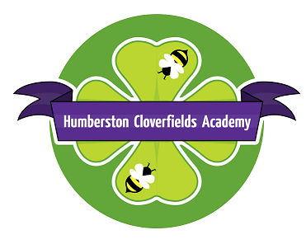

3 July, 2017

This has been a fast moving year with lots of success for the pupils. KS1 National Assessments were higher than last year as were the teacher assessments for KS2. We await the KS2 test results next week where we can compare ourselves with schools nationally. We know how hard all of these children have worked and the application and concentration on the test days was exceptional so we hope they get the results they deserve.

Across the school we have been working on collaboration. One of the changes is that pupils are placed with a randomly selected learning partner for the week. This ensures that pupils learn to work with everyone and build a better classroom community of tolerance. Working together and supporting each other supports them with gaining the life skills that will be important in later years.

We proudly won our local football tournament and did the same when 19 Enquire Trust schools came to Blundell Park. We are looking forward to doing many more events with Trust schools next year. A team of 4 mathematicians entered the local schools maths challenge. The standard was very high with "head scratching" questions but they came second, which was a fantastic success.

In Miss Fairclough's class, a Formula 1 competition took place with two teams going forward to the National Finals in Coventry. They were nominated for Best Presentation and were also winners of the Research and Development Award. Next year Miss Fairclough will be offering this competition to Year 5 pupils as an after school club.

The office would request that if any Year 6 children have medication in school, could this be collected before the end of term. If your Year 6 child as any outstanding balances on Parentpay, please ensure these are paid asap. If there are any credits on your child’s account, these will either be transferred to a sibling within school or a refund issued.

Staff changes for September

Mrs Mickleburgh is retiring at the end of the term. She has been at Cloverfields for over 17 years. We wish her all the best in her retirement. Miss Kophazy will be joining us from September as a KS1 teacher. We look forward to welcoming her to Cloverfields.

Mrs Clarke is continuing her maternity leave and her class will be taught in the meantime by Mrs White.

Diary events- end of term

Pupils in year 6 will have received a separate events letter.
19th July – Year 6 Picnic in the Park (details to follow)
20th July – Year 6 Heart Start First Aid Training

18th July – Concert - Choir and music performances from across the school- letter to follow.

Sports Day Monday 24th July- am Reception Y1 and Y2; pm Y3-Y6

School closes on Tuesday 25th July at 2.30pm.

Any further updates or additional events will sent by text message.

We wish our Year 6 pupils a fantastic end to their time at Cloverfields with the events planned and all the best wishes for their futures. We hope all our pupils have an enjoyable summer and look forward to seeing you on Wednesday 6th September.

