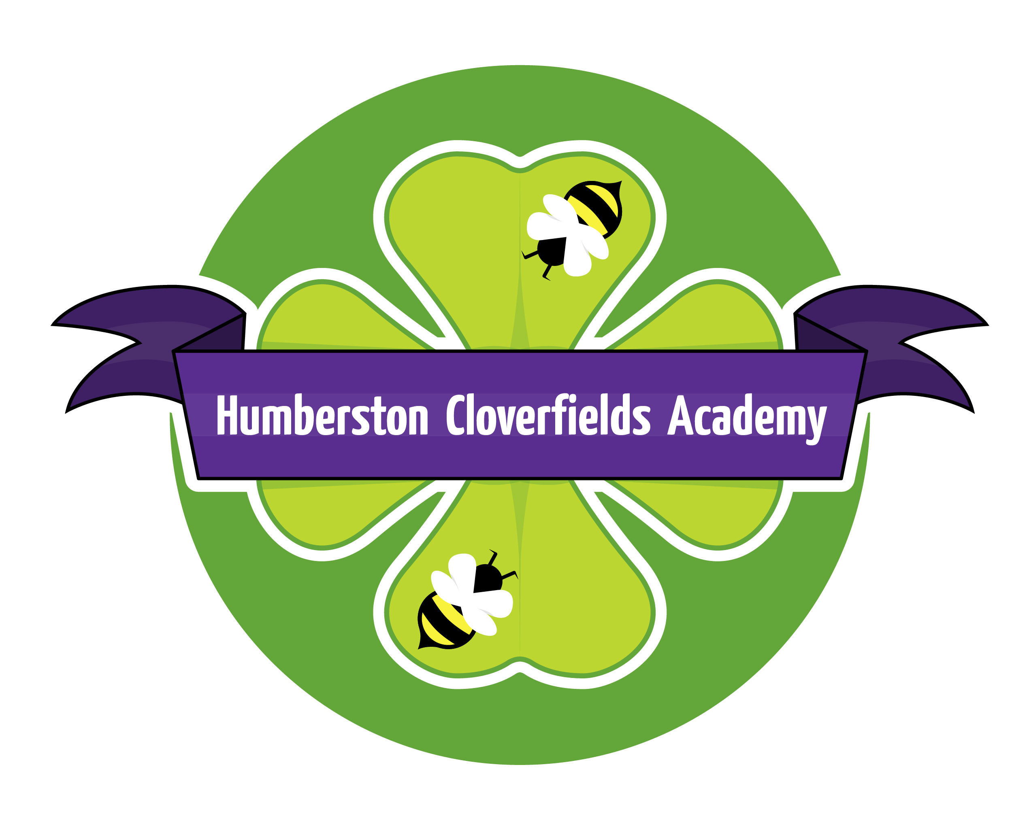

Humberston Cloverfields Academy
Special Educational Needs
and
Disabilities Policy
Policy Statement:
This policy has been written by the SENDCo of Humberston Cloverfields Academy. It has been developed jointly with the Principal and agreed by the Governing Body.
This policy document is a statement of the aims, responsibilities and strategies we have agreed, to ensure the effective and efficient provision for children with Special Educational Needs (Leaming Support Needs) at Humberston Cloverfields Primary Academy. It takes into account the Education Act (1996), the Special Needs and Disability Act (2001), the Equality Act (2010), the Children and Family Act (2014), statutory guidance on Supporting Pupils at School with Medical Conditions (2014), The 0-25 Special Educational Needs and Disability Code of Practice (2014), and The Special Educational Needs and Disability Regulations 2014.
Our SENDCo at Cloverfields is Denise Atkin who holds the National Award for SEN.
Aims and Values
All children have skills, talents and abilities and as a school we have a responsibility to develop these to the full, no matter the learning or additional needs of the child. At Humberston Cloverfields Academy, we endeavor to
- Ensure that the necessary provision is made for any pupil who has special educational needs, considering them within the wider context of inclusion
- Make those special educational needs known to all who are likely to teach them
- Maintain high expectations for all pupils, including those with SEND
- Ensure that teachers in the school are aware of the importance of identifying and providing for, those pupils who have special educational needs.
- Ensure that the culture in school is such that a pupil with special educational needs is socially included in all the activities of the school and receives a balanced and broadly based curriculum, promoting the highest level of achievement.
- Have regard to all relevant policy and legislation in the decisions we make as a school
- Identify at the earliest opportunity all children who need special consideration to support their physical, sensory, emotional, communication or cognitive development.
- Use the procedures outlined in The 0-25 Special Educational Needs and Disability Code of Practice (2014) to identify, assess and make provision for pupils with Special Educational Needs.
- Consider parents and pupils as central to effective provision, nurturing a positive partnership of support.
- Strive to provide the best setting we can to meet the needs of children with SEN, continually monitoring and evaluating the site and resources in order to effect improvements.
- Work closely with external agencies when necessary and appropriate, in order to ensure that pupils and their families have access to all available, necessary and relevant support.

Definition of Special Educational Needs
Humberston Cloverfields Academy recognises a pupil as having SEND if they have a learning difficulty or disability which calls for special educational provision to be made for them, as outlined by The 0-25 Special Educational Needs and Disability Code of Practice (2014). A child of compulsory school age or a young person is understood as having a learning difficulty or disability if they
- Have a significantly greater difficulty in learning than the majority of others of the same age; or
- Have a disability which prevents or hinders them from making use of educational facilities of a kind generally provided for others of the same age in mainstream schools or mainstream post-16 institutions.
These difficulties are considered to fall into one or more of the following categories:
- communication and interaction,
- cognition and learning,
- social, emotional and mental health
- sensory and/or physical needs.

Humberston Cloverfields Academy recognises that where a pupil displays poor behaviour in school it is a response to a need, which we will seek to identify.
Where a child or young person has a disability or health condition which requires special educational provision to be made, they will be covered by the SEND definition. In addition, there are a number of factors which may impact progress and attainment which are not considered under the definition of SEND. These include:
- attendance and punctuality,
- health and welfare,
- English as an Additional Language (hereby referred to as EAL),
- being in receipt of a Pupil Premium Grant,
- being a Looked After Child
- being the child of a serviceman/woman.

The Role of the SENDCo
At Humberston Cloverfields Academy, the SENDCo coordinates, manages and reviews the provision for pupils with Special Educational Needs and/or Disability. With the support of the Principal and governing body, she takes responsibility for the day-to-day operation of provision made by the school for pupils with SEND and provides professional guidance for all staff in the area of SEND in order to secure high quality teaching and the effective use of resources to bring about improved standards of achievement for all pupils.
This includes,but is not limited to:
- Monitoring the day-to-day operation of the school's SEND policy.
- Liaising with and advising all staff
- Co-ordinating provision for children with special educational needs.
- Maintaining the school's Special Educational Needs register, and overseeing the records kept for all pupils with special educational needs.
- Reviewing all policy and official documentation in good time.

- Ensuring lines of communication with parents of children with special educational needs are open and accessible, and encouraging effective home-school partnerships to develop.
- Contributing to the in-service training of staff.

- Liaising with external agencies including the educational psychology service and other support agencies, medical and social services and voluntary bodies in order to access additional and relevant support for those pupils for whom it is required.
- Promoting a child-centered approach to provision throughout the school.
- Encouraging a joined-up approach to provision, from the EYFS (including Nursery) through to Year 6.
Our Graduated approach to SEN Support:
Humberston Cloverfields Academy identifies initial concerns about children through the graduated approach as outlined in The 0-25 Special Educational Needs and Disability Code of Practice (2014), following the Assess-Plan-Do-Review approach.
Initial concerns regarding a pupil's progress, attainment, wellbeing or inclusion are raised in the first instance through the following strategies, which are also used to review and monitor progress once a pupil is identified as having SEND
- Liaison with pre-school provision and/or previous schools
- EYFS profiles and phonic assessment in reception and standardised tests throughout Years 1-6, including SATs.
- Additional range of assessments carried out individually as appropriate.
- Liaison with teachers who assess their pupils on a regular basis, in line with the school Assessment Policy
- Liaison with parents through the usual parent-teacher consultation and individual contact between school-parent and parent-school
- Liaison with external agencies where pupils may have been known to their service(s).
- In-class observations conducted by the SENDCo, or other members of the Senior Leadership Team (hereby referred to as the SLT)
- Work sampling and analysis
- Opportunities to explore pupil's own views, for instance during target setting tasks.
- Concern forms
- In class target setting and monitoring
Once concerns have been raised, discussions are held between class teacher-parent-SENDCo to assess a child’s needs and identify support and strategies needed to meet those needs. Plans will be made, targets set and a time frame given in order to review progress. A decision will be made at this point as to whether or not to place the child on the SEN register.
Once a child is placed on the SEN register they will be classed as receiving SEN support. Again, following the ASSESS-PLAN-DO-REVIEW approach in accordance with The 0-25 Special Educational Needs and Disability Code of Practice (2014), after the initial joint meeting a Personal Support Plan (PSP) will be written jointly with SENDCo, class teacher, parent and child. This is a working document which gives detailed specific, achievable targets which are reviewed on a termly basis. The targets are always responsive and relevant to a pupil’s individual learning needs.
In accordance with The 0-25 Special Educational Needs and Disability Code of Practice (2014), class teachers continue to be responsible and accountable for the progress and development of the pupils in their class with the SENDCo offering support and guidance.
If, despite the additional support and input received a pupil continues not to make desired or appropriate progress, or their wellbeing remains a concern, advice and input will be sought from external agencies, with parental permission. Advice from external agencies may include specialist assessments, advice on targets, teaching approaches and materials. As, and when, advice has been received, it will be shared with parents, teachers and support assistants as appropriate.
Where a pupil has a number of agencies are involved in their support, a Single Assessment Framework may be established, along with regular meetings, to ensure that all those involved are working together effectively to meet the needs of the pupil.
Parents are informed of the school's concerns at every stage and are included in discussions to gather appropriate relevant information about the child. The school recognises that effective communication will nurture successful parent partnerships, which in turn will facilitate improved learning outcomes for pupils. Pupils who require additional support will also have their needs considered when sitting both internal and external examinations in terms of special arrangements.
It is expected that, in most cases, pupils classed as SEN Support will be removed from this stage when their additional needs are met, eventually returning to being monitored and supported through whole class provision alone.

Medical Conditions
Humberston Cloverfields Academy keeps a separate record of children who have a diagnosed medical condition. A medical condition is not an automatic indicator of an SEN need. Children will only be identified as needing SEN support if that medical condition impacts on their learning as outlined in The 0-25 Special Educational Needs and Disability Code of Practice (2014).

Education Health Care Plans (EHCP)
Where a child continues to demonstrate significant cause for concern, or when multiple agencies are involved or required, an application may be made to the LA for an Education Health Care Plan. If issued, the EHCP will establish their specific needs and the range of provision suitable to meet those needs. Humberston Cloverfields Academy will carry out the specific requirements outlined in the EHCP.
Where a child has an EHCP, these will be reviewed annually and updated or resubmitted (if appropriate) accordingly.
Parent Partnership:
At Humberston Cloverfields Academy, we aim to promote a partnership with parents. We will do this through
- Involving parents as soon as concerns are raised.
- Ensuring all parents are made aware of the arrangements of Learning Support including the opportunities for meetings between parents and SENDCo both formally at Parents' Evenings and informally, by agreement.
- Providing open door access to the SENDCo to discuss the child's needs and approaches to address them
- Supporting parents' understanding of relevant legislation, including but not limited to The 0-25 Special Educational Needs and Disability Code of Practice (2014), and other external agency advice and support.
- Undertaking Annual Reviews for children with EHCPs.
Resources Available and Access Arrangements
The school also has a wide range of resources, including specific ICT programmes, to assess and support children with varying needs, including:
- Literacy
- Mathematics
- Speech Language and Communication
- Social and Emotional
- Behaviour
- Visual and Auditory
- Fine and Gross motor
- Dyspraxia
- Dyslexia
- Autism

They are updated regularly and in addition, advice and resources are sought from outside agencies as needed.
The school aims to ensure that the curriculum, site and facilities are fully accessible to children with learning support needs. In the light of evidence about a child's particular needs, provision can include
- Improving access as far as is reasonable through physical changes to the school buildings and by providing extra resources.
- Appropriate and effective classroom management plans, with planning, differentiation and resources to meet the individual's needs, to include considerations taken for planning of trips and visits
- Ongoing consultation with parents and pupil
- Developing and maintaining links with support agencies, other mainstream schools and special schools through visits, membership of professional bodies, etc.
- Alerting all teachers and support staff to the child's needs and providing appropriate training and literature.
- Helping the child develop appropriate practices for taking down and recording information eg by using a laptop or providing a scribe.
- Providing alternative sources of information.

For further information regarding accessibility arrangements, and removal of barriers to learning, please see our Accessibility Plan.
Transitions:
At Humberston Cloverfields Academy we value communication in order to best support our pupils. With this in mind, at the end of each academic year, handover sessions take place to allow staff to share pupil information regarding the class they are passing on, and the one they are to take over. Detailed files and copies of assessments, work samples, associated letters and other important documentation follows the child through their time at school. Humberston Cloverfields Academy is also committed to ensuring that the transition for all of our pupils to their new schools is managed as carefully and as sensitively as possible. With this in mind, receiving schools are, as far as possible, given a comprehensive and complete overview of the needs of our pupils with SEND, the support historically in place for them during their time at Humberston Cloverfields Academy and our view of the support that will be necessary for them to receive on arrival at their new school. The SENDCo will ensure she responds to all information requests submitted by receiving schools, and all members of staff with support parents and pupils with their selection of appropriate secondary or other schools.
Staff Development:
In order to maintain a high standard of teaching and learning across the school, with particular focus on meeting the needs of SEND pupils, Humberston Cloverfields Academy ensures the following:
- That staff will attend Learning Support/SEND courses, which are of interest and have a particular bearing on children they are supporting. In order to maintain and develop the quality of teaching, all staff are encouraged to undertake training and development.
- That the SENDCo will provide appropriate INSET and training in school, will source external and specialist speakers, and will respond to the training requests of all teaching staff, wherever possible. That staff are given regular opportunities through a range of means to share and discuss any concerns of queries they may have in terms of the learners with SEND in their classes
- That the school SENDCo regularly attends any local training and that provided by the Enquire Learning Trust
- That on arrival, new staff receive induction which includes an introduction to the school's approach to SEND provision and the expectations the school places on all staff in terms of supporting all their learners, including those requiring additional support.
Confidentialitv
Our work with children and families will sometimes bring us into contact with confidential information. To ensure that all those working at Humberston Cloverfields Academy can do so with confidence, we will respect confidentiality in the following ways-

Parents will have ready access to the files and records of their own children but will not have
access to information about any other child.

- Staff will not discuss individual children, other than for the purposes of curriculum planning/group management, with people other than the parents/carers of that child.
- Information given by parents/carers to the school will not be passed on to other adults (not including Humberston Cloverfields Academy employees, members of the governing body and/or peripatetic teachers).
Roles and Responsibilities:
When considering the provision for pupils with SEND at Humberston Cloverfields Academy, the following members of staff are key to ensuring a cohesive and collaborative approach:
- Denise Atkin, SENDCo
- Matt Holness, our SEN Governor
- SEN TAs
Complaints Procedure:
Any concerns regarding the Learning Support Policy or the provision made for children with learning support needs should be addressed in the first instance to the class teacher. If parents need further advice they are welcome to arrange a meeting with the SENDCo. If you are still not satisfied that your concerns are being addressed you should make an appointment to see the relevant Head of Key Stage or alternatively, the Principal.
The Equality and Human Rights Commission (0845 604 6610) provides a range of information and guidance on the Disability Discrimination Act. This organisation would be able to advise if the concern relates to an issue of the possible discrimination of a disabled child. Contact details for support groups relating to different conditions and syndromes, and lists of chartered Educational Psychologists and therapists are available from the SENDCo on request.
Bullying:
Please view the school's Behaviour/ Antibullying Policy for a detailed overview of our approach to bullying at Humberston Cloverfields Academy. We are particularly vigilant when it comes to the bullying or victimisation of our vulnerable learners. Staff are asked to identify any incidents of bullying immediately, and these are dealt with, primarily by the Principal. A log of homophonic and racial abuse is also maintained. We nurture a culture of acceptance and tolerance, using circle time, SEAL, visitors, PSHE, and assemblies, amongst other strategies We promote inclusion for our SEND learners, and will implement social skills programmes or similar in the event that pupils with social communication difficulties, ASC or similar require additional support in this regard.
The SEN Policy is reviewed annually by the SENDCo as part of Humberston Cloverfields Academy's monitoring and evaluation cycle. The review includes looking at the effectiveness of identification and provision, efficiency of record keeping and resources, with the aim of continually reviewing and improving our provision.

We have also published our School’s Offer which gives more details about how we meet the needs of our SEN children and the school SEN information report. All are available on our website.
This policy was reviewed and adopted by Cloverfields Governing Body on 29/11/17
Signed: Mrs C Spruce (Principal)
Signed: Mr M Thompson (Chair of Governors)
This policy is due for review in September 2019

Focus: | What will you focus on – Equalities/accessibility plan |  | Leader: Principal
Preferred future | The primary aim of Humberston Cloverfields Academy School is to enable all pupils to take part as fully as possible in every part of school life by developing each child ‘s self-confidence, recognising their strengths and encouraging them to achieve their full potential.
Objective | Aspect of Duty | Action |  | Responsibility | Resource |  | Timescale
To maintain a “New Arrivals” Policy to ensure that all pupils regardless of previous background are fully included in all aspects of school life. | Advance equality of opportunity  New arrival policy for Foundation | Maintain New Arrival policy. New buddy package  Maintain same for Foundation |  | Principal  S Chidwick | TAs Teaching staff children  Nursery and Foundation staff |  | Ongoing Sept 2015  Ready for summer term
ALL SEND pupils are to make progress to be at least in line with SEND pupils nationally. Those with high needs if not in line with National to have made good progress from starting point. | Advance equality of opportunity | All staff to have training on new Individual Support Plans.  All staff to engage in quality first teaching for SEND pupils. |  | Principal  SENCO-  D Atkin  All teaching staff | Data tracking  Observations  Pupil conversations  Individual staff CPD |  | Ongoing start date Sept 2015
All pupils to make at least two levels of progress across KS1-2 in English and Maths regardless of ethnicity, gender or language | Advance equality of opportunity | All pupils regardless of gender, faith, culture or socioeconomic background make good progress during their time at school and achieve outcomes at least as high as other similar pupils nationally. |  | Principal | Data tracking  Observations  Pupil conversations  Individual staff CPD  Pupil progress meetings |  | Ongoing start date Sept 2014

Success criteria:  Headline performance indicators: |  |  |  | Monitored by
Milestones |  |  |  | Strategic committee
Half term 4 | Half term 5 | Half term 6 | Half term 1 | Half term 2
 | Create New Arrivals policy and buddy package | New arrivals buddy package complete Launched with TAs/teachers- pupils? | New children settle well into school and are happy to come to school. Check progress one year on from each new arrivals date.
New curriculum tracking shows good progress for all pupils. |  | KS1/KS2 results show good progress against National

This plan is edited and monitored as part of the Improvement plan.

